Scientific Inquiry Study Guide
Use your notes to answer the following questions. Turn in your completed study guide on test day.
1. What is the proper format for a hypothesis?

2. What is the proper format for a scientific question?

3. In a controlled experiment how many variables should be changed?

4. What is an independent variable?

5. What is a dependent variable?

6. In an experiment what is a control group? What is its purpose?

7. What is a qualitative observation?

8. What is a quantitative observation?

9. When presenting data, when should a line graph be used?

10. When presenting data, when should a bar graph be used?

11. When labeling a graph where should the Independent Variable go?

12. When labeling a graph where should the Dependent Variable go?

13. In the lab what is the purpose of the following items:
  - Metric Ruler-
  - Thermometer-
  - Graduated Cylinder-
  - Balance-
  - Compound Light Microscope-

14. What are the basic units for the following measurements?
  - Length-
  - Volume-
  - Mass-
  - Time-
  - Temperature

15. What scientific tool would a biologist use to examine the parts of a cell?

16. What scientific tool would a biologist use to compare the mass of two objects?

17. What scientific tool would a biologist use to measure the height of a plant?

18. What would be the unit of measurement for the mass of two objects?

19. What measurement is being displayed on the graduated cylinder below?
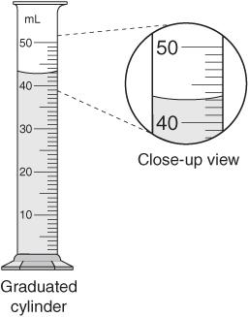

20. Is the statement “mealworms move faster when food is present” an example of a qualitative or quantitative observation?

21. Is the statement “my car was going 65 miles/hour” an example of a qualitative or quantitative observation?

A scientist who monitors the cleanliness of cafeteria trays found the organism Escherichia coli (E. coli) to be resistant to the common disinfectants ethanol and chlorine. The scientist investigated whether monochloramine would be more effective against E. coli. She designed an experiment in which she added ethanol, chlorine, and monochloramine to separate water samples. She then tested the water for populations of E. coli.

22. What is the independent variable in this experiment?

23. What is the dependent variable in this experiment?

24. Elijah is studying the effect of depth on oxygen concentration in lakes. He hypothesizes that, as the depth increases, then the oxygen concentration will decrease. Which set of results would best support Elijah’s hypothesis.

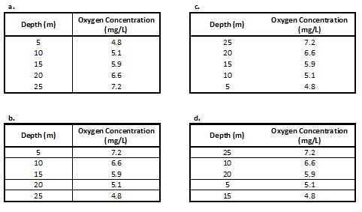

A researcher studying the effects of fertilizer on plants divided her plants into four groups and gave each 10 mg of fertilizer. All plants were fertilized at 10:00 am and their heights were measured every day for 5 days.
      - Plant 1 received 10 mg of Fertilizer A
      - Plant 2 received 10 mg of Fertilizer B
      - Plant 3 received 10 mg of Fertilizer C
      - Plant 4 received no fertilizer.

25. Why were plants 1, 2, and 3 given the same amount of fertilizer?

26. List 2 constants in this experiment.

27. Which plant served as the control group in the study?

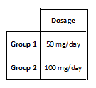
28. A medication that prevents allergies was given to two experimental groups during a scientific study. Their data is shown in the table below.

After 8 weeks, neither experimental group reported having any allergies. Upon peer review several colleagues pointed out there was no control group in this experiment. Describe an appropriate control group that would have made the outcome of this study more valid.

