Notes: Parts of a Eukaryotic Cell Part 2
Review: The 4 main functions of the cell.

11. Catabolism Organelles and Structures

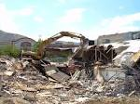
12. Energy Processing Organelles and Structures

13. Support/ Communication Organelles and Structures.

14. Cytoskeleton  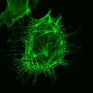 | 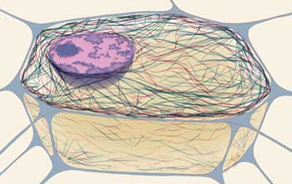
15. Centrioles  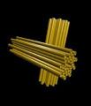 | 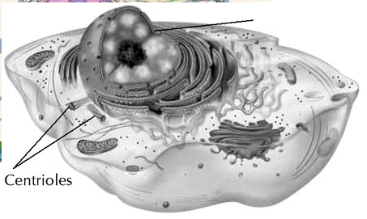
16. Vacuole

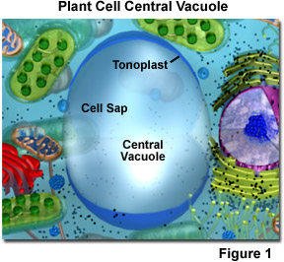
17. Cell Wall  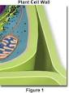 | 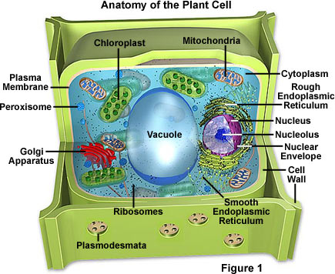

Animal/Plant Cell Labeling
1. Nucleus | 5. Smooth ER | 9. Vacuole | 13. Plasma Membrane
2. Nucleolus | 6. Golgi Apparatus | 10. Mitochondria | 14. Cell Wall
3. Ribosomes | 7. Peroxisome | 11. Chloroplast
4. Rough ER | 8. Lysosome | 12. Centrioles

